Dominick Girard  
CSCI 3236 Homework #7

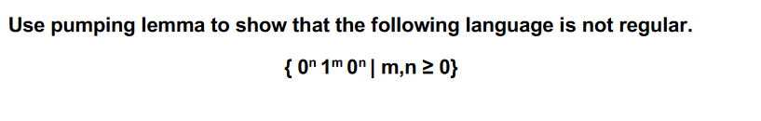

L =

According to the pumping lemma, there exists a pumping length p such that any string s in L with ∣ s ∣ ≥ p can be split into parts x,y,z where:

1. ∣xy∣≤p
2. ∣y∣>0
3. For all i≥0i≥0, xy^iz∈L

which belongs to L  
  
If y is pumped to i=0 (removing y), the resulting string x y^0 z will have fewer zeros in either the first or last segment, violating the condition that the number of zeros in these segments must be equal.

**Conclusion**

Since the resulting string x y^0 z is not in L when y is pumped down, L cannot be regular (as it fails the conditions of the pumping lemma).